Лабораторная работа №1.

**Постановка задачи:**

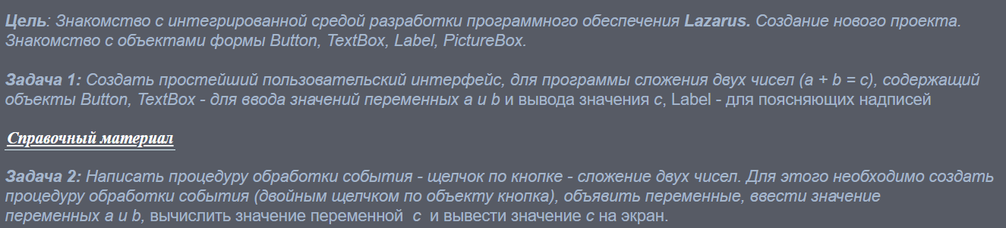

**Код программы:**

var

Form1: TForm1;

a, b, c: Real;

zn: String;

implementation

{$R *.lfm}

{ TForm1 }

procedure TForm1.ClickBut(Sender: TObject);

begin

Edit1.Text:=Edit1.Text+(Sender as TButton).Caption;

end;

procedure TForm1.ClickZn(Sender: TObject);

begin

a:=StrToFloat(Edit1.Text);

Edit1.Clear;

zn:=(Sender as TButton).Caption;

end;

procedure TForm1.Button18Click(Sender: TObject);

var

str: String;

begin

str:=Edit1.Text;

if str <>'' then

Delete(str, Length(str),1);

Edit1.Text:=str;

end;

procedure TForm1.Button17Click(Sender: TObject);

begin

Edit1.Clear;

end;

procedure TForm1.Button11Click(Sender: TObject);

begin

b:=StrToFloat(Edit1.Text);

Edit1.Clear;

case zn of

'+': c:= a + b;

'-': c:= a - b;

'x': c:= a * b;

'\': c:= a / b;

end;

Edit1.Text:=FloatToStr(c);

end;

end.

**Результат:**

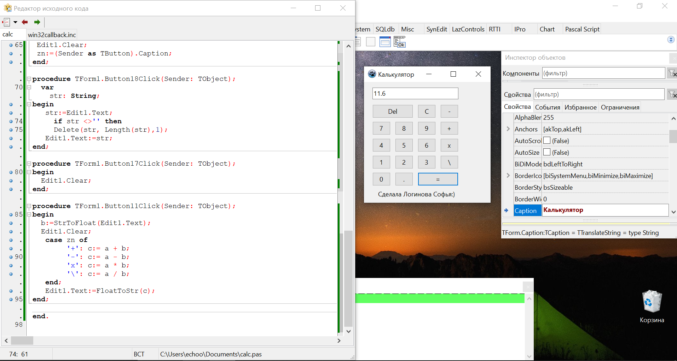

Лабораторная работа №2.

**Постановка задачи:**

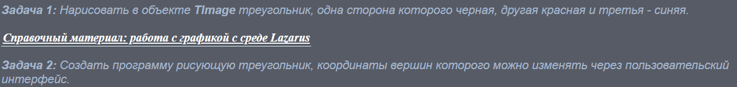

**Код программы:**

procedure TForm1.Button1Click(Sender: TObject);

var y2,y1,x2,x1,x3,y3:integer;

begin

Image1.Canvas.Rectangle(0,0,Image1.Width,Image1.Height);

x1:=StrToInt(Edit1.Text);

y1:=StrToInt(Edit2.Text);

x2:=StrToInt(Edit3.Text);

y2:=StrToInt(Edit4.Text);

x3:=StrToInt(Edit5.Text);

y3:=StrToInt(Edit6.Text);

Image1.Canvas.Pen.Color:= clBlue ;

Image1.Canvas.MoveTo(x1,y1);

Image1.Canvas.LineTo(x2,y2);

Image1.Canvas.Pen.Color:= clred ;

Image1.Canvas.LineTo(x3,y3);

Image1.Canvas.Pen.Color:= clblack ;

Image1.Canvas.LineTo(x1,y1);

end;

**Результат:**

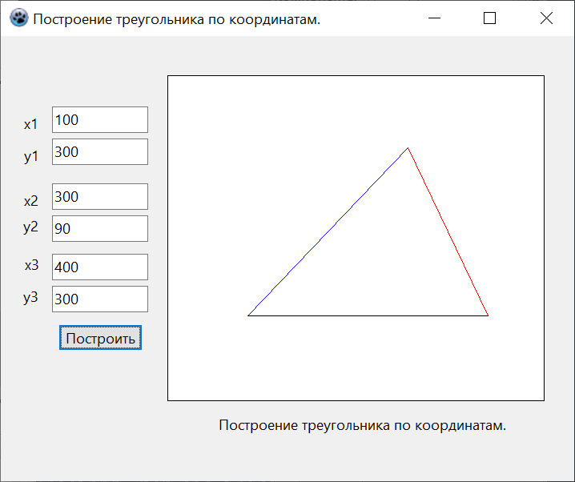

Лабораторная работа №3.

**Постановка задачи:**



**Код программы:**

procedure TForm1.Button1Click(Sender: TObject);

var x,y: integer;

begin

Image1.Canvas.Clear;

Image1.Canvas.Brush.Color:=clwhite;

Image1.Canvas.FillRect(0,0,Width,Height);

Image1.Canvas.pen.Color := clblack;

Image1.Canvas.MoveTo(252,0);

Image1.Canvas.LineTo(252,504);

Image1.Canvas.MoveTo(0,252);

Image1.Canvas.LineTo(504,252);

x:=trunc(StrtoInt(Edit1.Text));

y:=-trunc(StrtoInt(Edit3.Text)*x*x+StrtoInt(Edit4.Text)*x+StrtoInt(Edit5.Text));

Image1.Canvas.MoveTo(252+x*10,252+y*10);

Image1.Canvas.pen.Color := clred;

while (x<=(StrtoInt(Edit2.Text))) do

begin

x:=trunc(x);

y:=-trunc(StrtoInt(Edit3.Text)*x*x+StrtoInt(Edit4.Text)*x+StrtoInt(Edit5.Text));

Image1.Canvas.LineTo(252+x*10,252+y*10);

x:=x+1;

end;

end;

**Результат:**

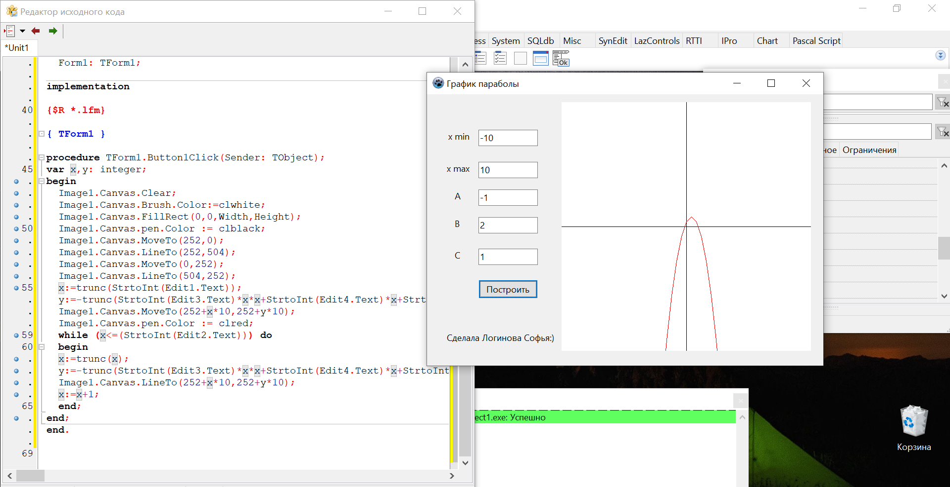

Лабораторная работа №4.

**Постановка задачи:**



**Код программы:**

procedure TForm1.Button1Click(Sender: TObject);

var u0,a,n,x,y,kx,ky,xd,yd,i:double;

begin

Image1.Canvas.clear;

Form1.Image1.Canvas.Brush.Color:=clwhite;

Form1.Image1.Canvas.FillRect(0,0,Width,Height);

Image1.Canvas.pen.Color:=clblack;

u0:=StrToFloat(Edit1.text);

a:=StrToFloat(Edit2.text)*pi/180;

n:=StrToFloat(Edit3.text);

kx:=(Image1.Width)/((u0*u0)/(9.8));

ky:=(Image1.Width)/((u0*u0)/(2*9.8));

i:=0;

while i<Image1.Width do

begin

xd:=u0*Cos(a)*i;

yd:=(u0*Sin(a)*i)-((9.8*i*i)/2);

x:=xd*kx;

y:=Image1.Height-yd*ky;

Image1.Canvas.LineTo(round(x),round(y));

i:=i+0.01;

end;

Image1.Canvas.pen.Color:=clred;

xd:=u0*Cos(a)*n;

yd:=(u0*Sin(a)*n)-((9.8*n*n)/2);

x:=xd*kx;

y:=Image1.Height-yd*ky;

Image1.Canvas.EllipseC(round(x),round(y),4,4);

end;

**Результат:**

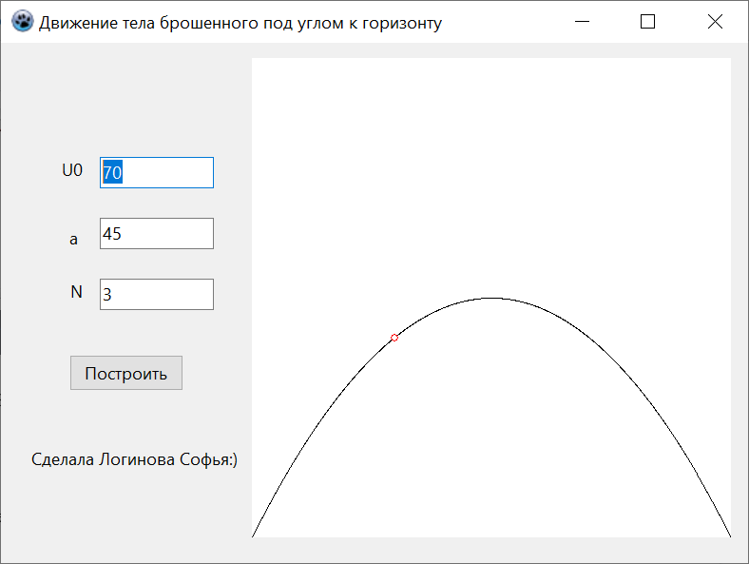

Лабораторная работа №5.

**Постановка задачи:**



**Код программы:**

procedure TForm1.Button1Click(Sender: TObject);

var n, i, r : integer;

var x, y : double;

begin

r := 60;

n:=StrToInt(Edit1.Text);

Image1.Canvas.clear;

Image1.Canvas.Brush.Color:=clwhite;

Image1.Canvas.FillRect(0,0,Width,Height);

x:=r*cos((2*pi*0)/n);

y:=r*sin((2*pi*0)/n);

Image1.Canvas.Pen.Color:=clwhite;

Image1.Canvas.LineTo(round(x),round(y));

for i:=0 to n do

begin

x:=r*cos((2*pi*i)/n);

y:=r*sin((2*pi*i)/n);

Image1.Canvas.LineTo(round(x),round(y));

Image1.Canvas.Pen.Color:=clred;

end;

end;

**Результат:**

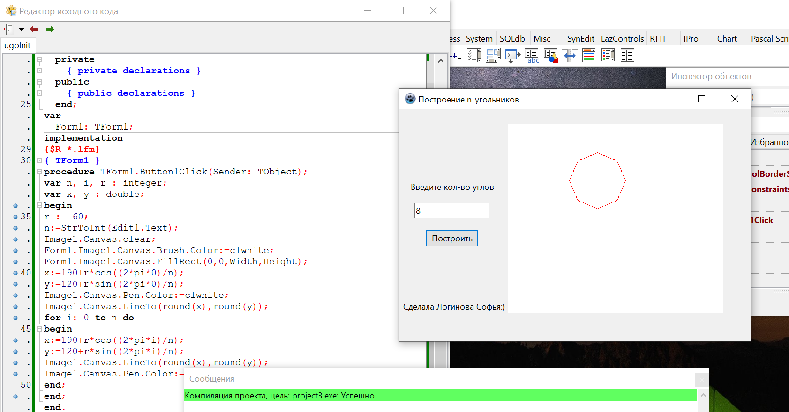

Лабораторная работа №6.

**Постановка задачи:**

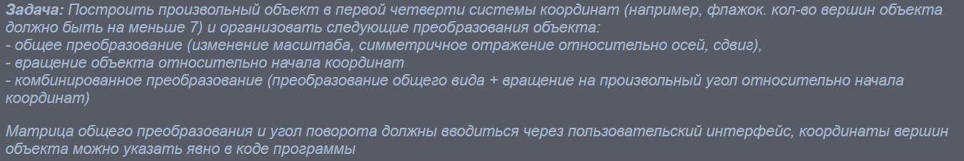

**Код программы:**

procedure TForm1.Button1Click(Sender: TObject);

var

fl: array[1..6,1..2]of integer=((20,20),(20,60),(60,60),(40,50),(60,40),(20,40));

u, a,b,p,c,d,q,m,n,s,x,y,corx, cory, W, H: integer;

i: integer;

begin

u:=StrToInt(Edit1.Text);

a:=StrToInt(Edit2.Text);

b:=StrToInt(Edit3.Text);

p:=StrToInt(Edit4.Text);

c:=StrToInt(Edit5.Text);

d:=StrToInt(Edit6.Text);

q:=StrToInt(Edit7.Text);

m:=StrToInt(Edit8.Text);

n:=StrToInt(Edit9.Text);

s:=StrToInt(Edit10.Text);

W:= Image1.Width;

H:= Image1.Height;

corx:= round(W/2);

cory:= round(H/2);

Image1.Canvas.Rectangle(0, 0, W, H);

Image1.Canvas.pen.Color := clblack;

Image1.Canvas.MoveTo(corx,0);

Image1.Canvas.LineTo(corx,W);

Image1.Canvas.MoveTo(0,cory);

Image1.Canvas.LineTo(H,cory);

for i:= 1 to 6 do

begin

x := round((a*fl[i,1]+c*fl[i,2]+m)/(p*fl[i,1]+q*fl[i,2]+s));

y := round((b*fl[i,1]+d*fl[i,2]+n)/(p*fl[i,1]+q*fl[i,2]+s));

fl[i,1]:= round(x*cos(u)-y*sin(u));

fl[i,2]:= round(x*sin(u)+y*cos(u));

end;

Image1.Canvas.pen.Color := clred;

Image1.Canvas.MoveTo(corx+fl[1,1],cory-fl[1,2]);

for i:= 1 to 6 do

begin

Image1.Canvas.LineTo(corx+fl[i,1],cory-fl[i,2]);

end;

end;

**Результат:**



